

**Bachelor of Science in Computing**

**Software Engineering**

**Year 2022-23 / Semester 2**

Internal Examiner: Wei Ren

Internal Moderator: Wenhao Fu

External Examiner: Maria Barry

Date: 24/04/2023

Duration: 2 Hours

Time: 10:00-12:00

Exam Weighting: 60%

Exam Delivery: Computer

**Instructions**

1. This paper contains 1 section with 1 question.
2. You must attempt all parts of the question.
3. All questions are marked out of 100.
4. Please write all answers on the script provided.
5. Clearly number all questions.
6. This is an open-book exam.

***Please do not turn over this page until instructed to do so****. The use of programmable or text storing calculators is expressly forbidden. Please note that where a candidate answers more than the required number of questions, the examiner will mark all questions attempted and then select the highest scoring ones.*

**Question 1**

Please answer the question based on the following scenario: You are managing a software development team that has been invited by “Dorset Bank” to develop an operating system for their ATM machines. The ATM machines should allow clients to withdraw money at any time and deposit cash or checks. Additionally, the machines should display the client's account balance. You have 4 weeks to do this project.

1. Select a development method for this project and provide the reason for your choice, (e.g. waterfall development method, agile development method, etc.).

**[14 marks]**

The development method I’d like to choose for this particular project is waterfall development method, The reason to choose waterfall method is because the requirements are well understood and not likely to change.

Since it is a sequential development process that flows like a waterfall through all phases of a project (analysis, design, development, and testing, for example), with each phase completely wrapping up before the next phase begins. So The customer is not prone to demanding changes. The customer prefers not to be involved in the development, but wants to be consulted at the beginning and receive a working package at the end of the project.

1. Provide a comprehensive list of the steps involved in the software development process.

**[5 marks]**

The steps involved in software development process are as follows,

* Requirement Gathering & Planning – in this phase all the essential requirements about the software are gathered and analysed to better understand what client is looking for.
* Design & Prototyping – Based on requirement document in this phase the software is designed which includes prototyping, wireframing, mockup etc.
* Development- in this phase the software is developed and based on user/clients requirements.
* Testing- This is the most important phase in software development as in this phase the software is tested which involve unit testing, integration testing, system testing, regression testing, Client Testing, UAT testing etc.
* Deploying – In this phase the software is finally deployed and is ready.

1. Write a requirement document based on the client's previous requirements, including functional requirements, interface requirements infrastructure requirements.

**[25 marks]**

**1.0 Introduction**

This is a project to develop an operating system for ATM machines. The ATM machines should allow clients to withdraw money at any time and deposit cash or checks, and it should display clients account balance.

**2.0 Functional Requirement**

2.0.1 User Authorization- When a user enter their ATM card they should be able to enter their pin in order to proceed.

2.0.2 Withdraw Money- If the pin is correct user should be able to withdraw money from their available balance and which should also update the remaining available balance.

2.0.3 Deposit Money - If the pin is correct user should be able to deposit money or deposit checks which should update the remaining available balance.

2.0.4 Balance Display- If the pin is correct user should be able to see their remaining available balance on the screen.

**3.0 Interface requirements**

3.0.1 User-friendly interface - The interface should be user friendly which means that it should be easy enough for a user with any disability to understand and use it.

3.0.2 Interactive interface - The user interface should be designed and deployed with an interactive display which should enhance User Experience and should be smooth throughout windows and layouts.

**4.0 Infrastructure requirements**

4.0.1 Help & Troubleshooting – In case of any help required user should be able to contact through telecom so the help can be provided.

4.0.2 Accessibility- The Operating system should be scalable which means during peak load time it should be able to manage and system should not crash.

**5.0 Conclusion**

To Conclude requirement Document for ATM Operating System contains all the requirements which are mandatory to achieve the OS of client’s expectation, and any improvements or changes should be discussed with clients.

1. Create a Use Case Diagram.

**[6 marks]**

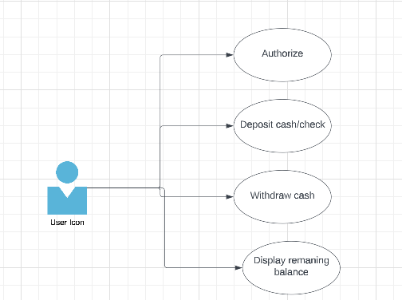

1. Create a Gantt Chart to manage development process.

**[10 marks]**

|  |  |  |  |  |
| --- | --- | --- | --- | --- |
| Task | week1 | week2 | week3 | week4 |
| Requirment Gathering |  |  |  |  |
| Design & Prototyping |  | |  |  |
| Development |  |  | |  |
| Testing |  |  | |  | | --- | |  | |  |
| Deploying |  |  |  |  |
|  |  |  |  |  |

* Requirement Gathering & Planning – 3 days
* Design & Prototyping – 4 days
* Development- 10 days
* Testing- 7 days
* Deploying – 4 days

1. Provide an example code snippet, in any programming language, that includes the class name, function name, and any other necessary variables, to demonstrate how to achieve the goals of this project. You do not need to include the implementation details of the functions. Please show class diagrams or template code.

**[20 marks]**

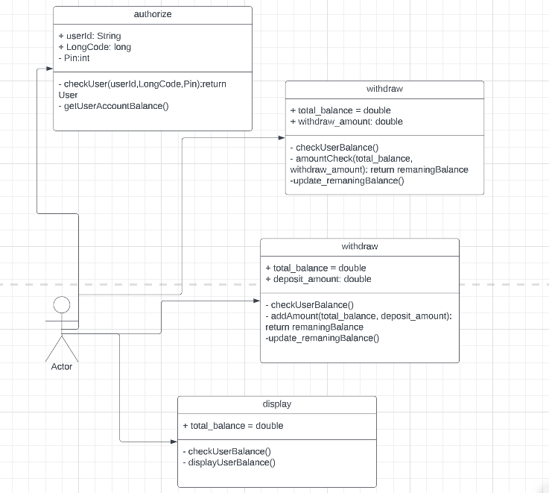

1. Provide a detailed explanation of the validation and verification process that should be followed to ensure the successful completion of this project.

**[15 marks]**

The detailed list of verification and validation for this operating system is as follows,

* Requirement review – In this phase the requirements provided and gathered are verified and analysed to make sure that all the client’s requirements are in our requirement document.
* Project Planning – In this phase the project planning is done which includes managing software development in given timeframe.
* Unit Testing- Unit testing is part of testing where individual module of a software is to make sure that each module of a software is proper functional.
* Integration Testing – Integration testing is a type of testing where interaction of modules are tested to make sure that modules are properly integrating when switching between modules.
* System Testing- System testing is testing the system as a whole where whole system is tested.
* Regression Testing – this is part where developed software is presented to client so that client can approve the software or if any changes need to be made.
* Next is the part where the software updated after regression testing.
* After verifying that the developed software is exactly what clients are looing for then next step comes of,
* UAT- In UAT testing software is tested with end-user to make sure the software is easy enough for an end user and it meets the requirements and expectations of an end user.
* Then Finally after all of testing the software is deployed and is good to be used.

1. Create a repository on GitHub and upload your answers to it. Please note that the answers on GitHub will not be considered for marking, so it is essential to submit all your answers to Moodle before the exam deadline.

**[5 marks]**

[**https://github.com/flast8021/SoftwareEngineringExam**](https://github.com/flast8021/SoftwareEngineringExam)

**[Total 100 marks]**

**----­­­-------------­­­-------------­­­---------End of document----­­­-------------­­­-------------­­­---------**

**Usman Zia**

**24087**

**24087@student.dorset-college.ie**

**----­­­-------------­­­-------------­­­-------------­­­-------------­­­-------------­­­-------------­­­-------------­­­-------------­­­-------------­­­------**